Week 05

Is it safe to use this free wireless hot spot?

*The following fictional story is based on real events.*

Sharon had never traveled by air so much in her life! It was so exciting to be selected to interview via internet video-conference for three different internship opportunities, and even more exciting that each of those three companies subsequently purchased a round-trip airline ticket. All three wanted her to visit their company for in-person follow-up interviews!

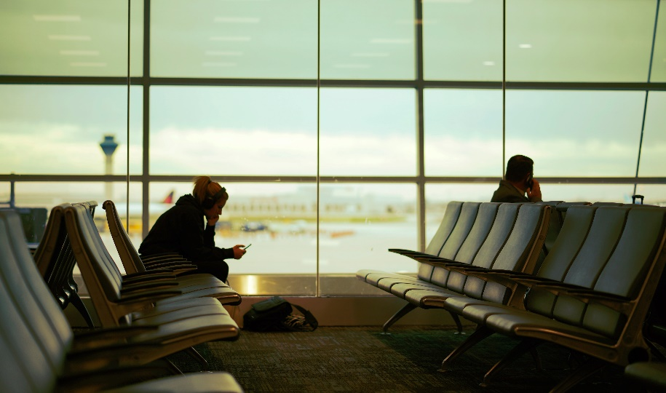

*(Image credit: Unsplash)*

Aware that she needed to keep up with her coursework while she was traveling, Sharon dutifully stayed current with her online homework assignments, using the free open wireless networks at the airports' waiting areas.

A few days after one of her flights, she noticed something strange. She started missing others' messages in her student email account. She also found two strange, unexpected charges on her student financial record. She phoned the university financial office to dispute the charges, and afterward, the I.T. service desk to find out what may have happened.

The following day, an I.T. manager called her back and let her know the results of their detective work: the day after her most recent flight, someone had logged into her learning management system from a foreign country. Soon afterward, it appeared that the same perpetrator accessed her other university accounts, changed her email forwarding rules, sent several emails using her address, and transferred money from her student financial account.